**Coding challenge**

**SQL**

**Name: Rohan Vinayak Chaudhari**

**Batch: Data Engineering 1**

**Question2: Execute all the join with examples.**

**1)Creating Extra table to implement join:**

**Created Extra table to connect with the order table and perform joins operation.**

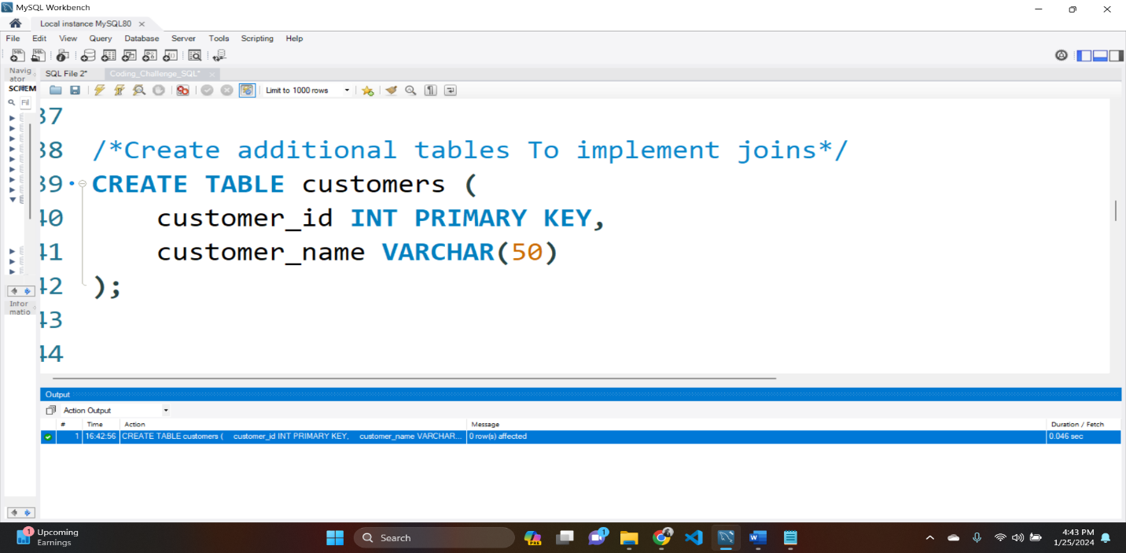

**2)Inserting data in Customers table:**

**Inserted data in the customers table**

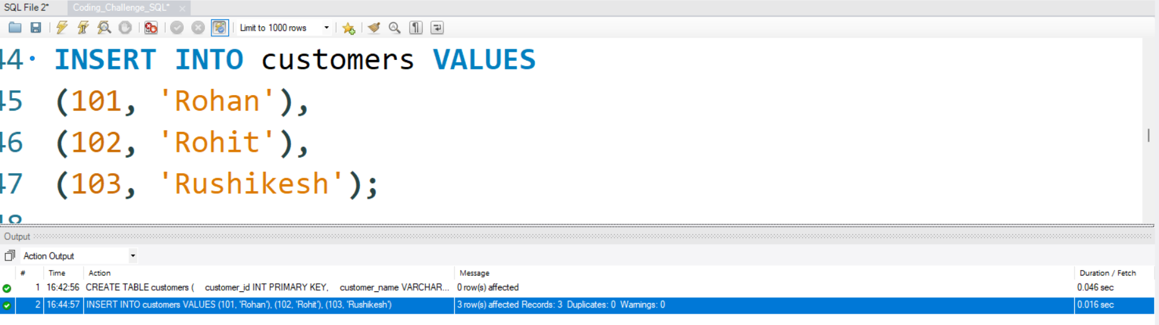

**3)Creating 3rd table**

**Created Extra table to connect with the order & customer table table and perform joins operation.**

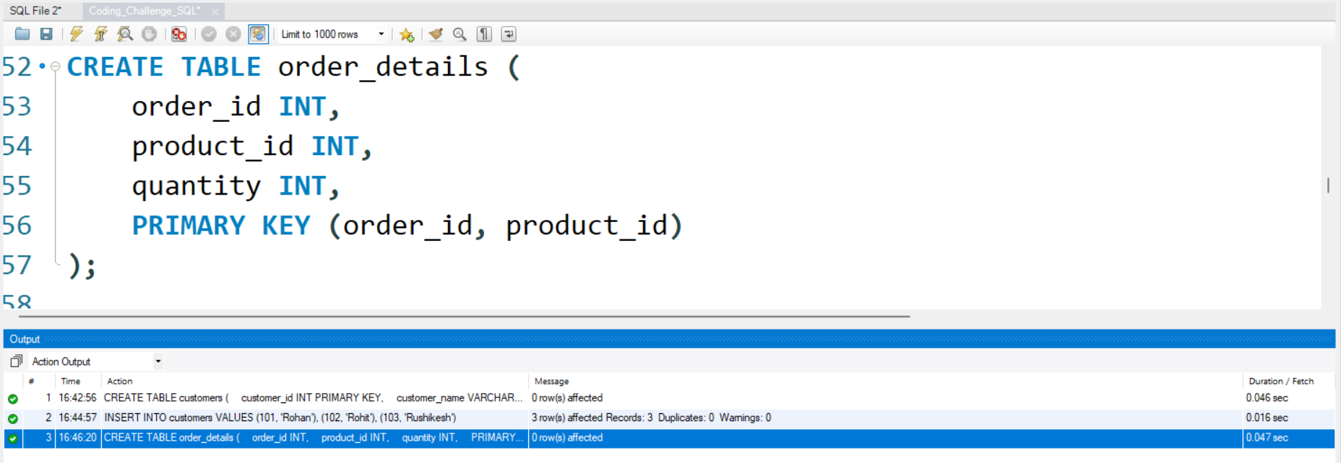

**4)Inserting data in order_details:**

**Inserted data in the order details table.**

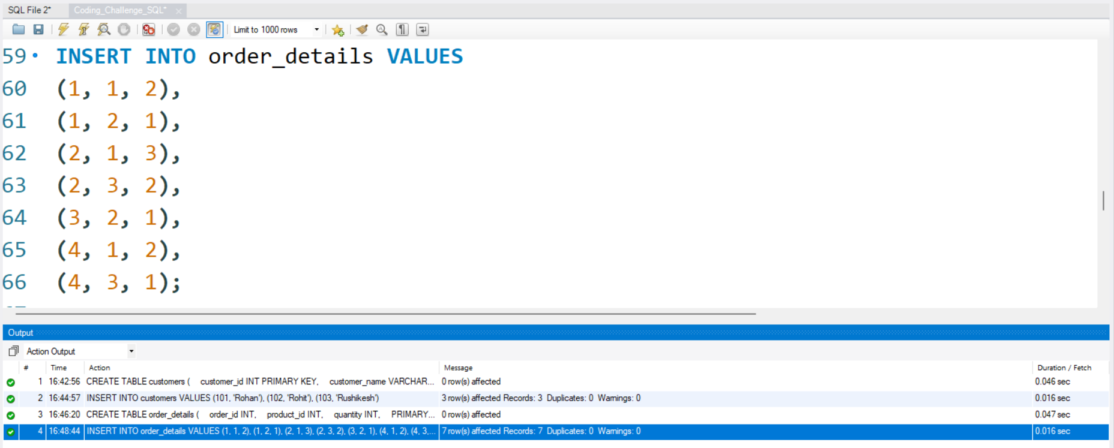

**5)Performing inner join:**

**Returns only the rows where there is a match in both tables based on the specified condition (orders.customer_id = customers.customer_id).**

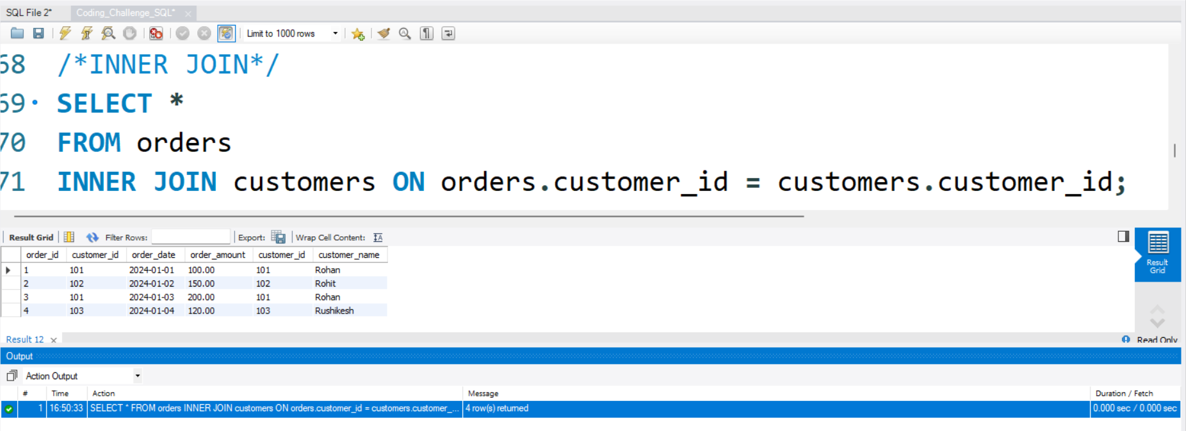

**6)Performing LEFT JOIN**

**Returns all rows from the left table (orders) and the matched rows from the right table (customers). If there is no match, NULL values are returned for columns from the right table.**

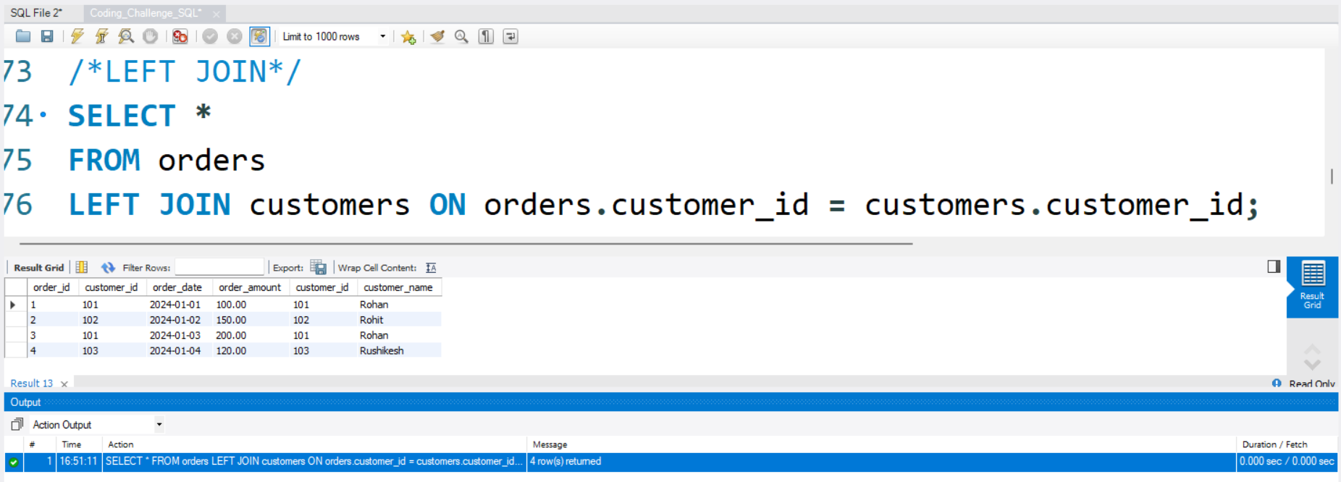

**7)Performing Right join:**

**Returns all rows from the right table (customers) and the matched rows from the left table (orders). If there is no match, NULL values are returned for columns from the left table.**

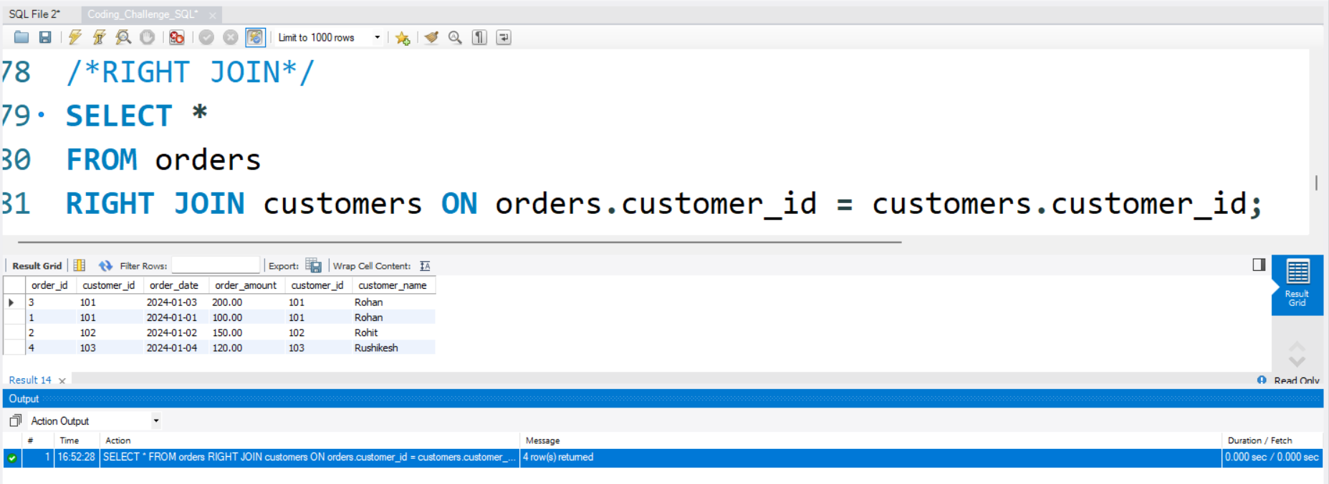

**8)Performing Cross join:**

**Returns the Cartesian product of rows from both tables, resulting in all possible combinations of rows from orders and customers.**

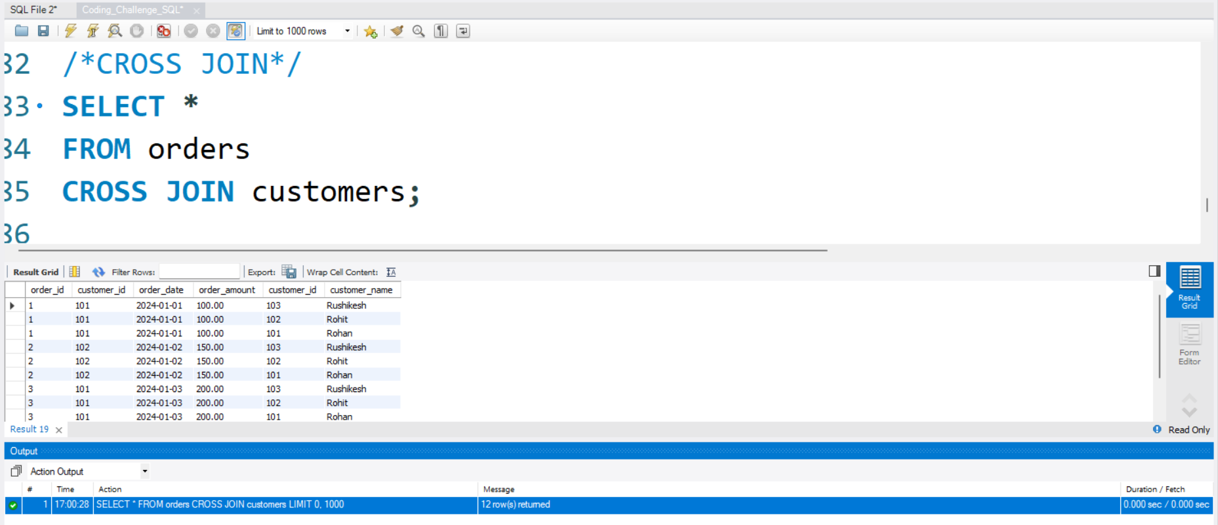

**9)Performing simple JOIN:**

**Gives all the result where data gets match with the given condition.**

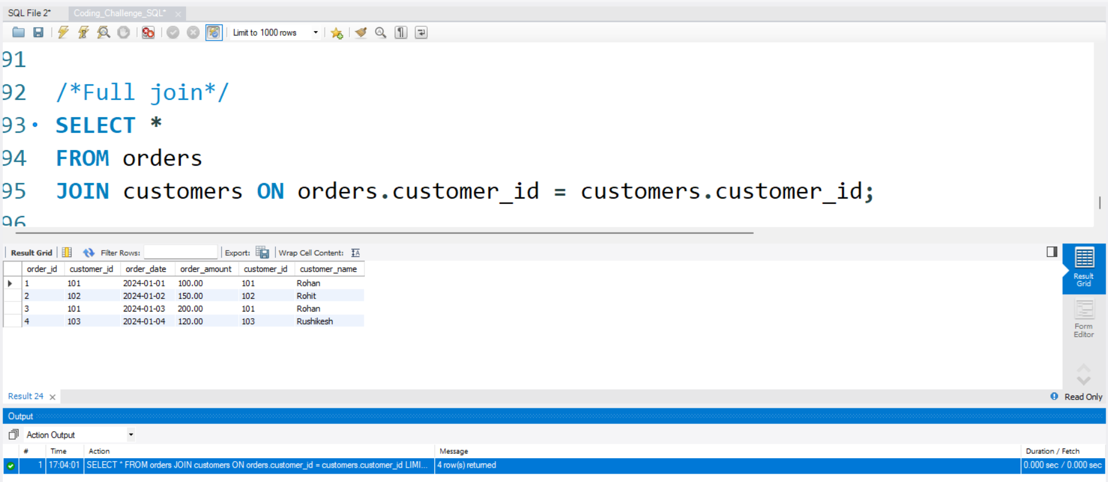

**10)Performing Self join:**

**Joins a table with itself. Here it retrieves rows from orders where the customer_id is the same, but the order_id is different, essentially finding pairs of orders for the same customer.**

